12.1_Assignment_CHathaway

Christine Hathaway

February 26, 2019

How has the uninsured rate changed since the ACA was enacted?

The biggest increase in coverage occurred in California, while the smallest was in North Dakota. The biggest increase in percentage was Nevada, while the smallest was in Massachusetts.

format(stat.desc(st_medex), scientific = FALSE)

## State State.Medicaid.Expansion..2016. Medicaid.Enrollment..2013.  
## nbr.val NA NA 49.000000  
## nbr.null NA NA 0.000000  
## nbr.na NA NA 0.000000  
## min NA NA 67518.000000  
## max NA NA 7755381.000000  
## range NA NA 7687863.000000  
## sum NA NA 56392477.000000  
## median NA NA 790051.000000  
## mean NA NA 1150866.877551  
## SE.mean NA NA 209192.034958  
## CI.mean NA NA 420608.776505  
## var NA NA 2144304067009.151367  
## std.dev NA NA 1464344.244708  
## coef.var NA NA 1.272384  
## Medicaid.Enrollment..2016. Medicaid.Enrollment.Change..2013.2016.  
## nbr.val 49.000000 49.000000  
## nbr.null 0.000000 0.000000  
## nbr.na 0.000000 0.000000  
## min 63583.000000 -3935.000000  
## max 11843081.000000 4087700.000000  
## range 11779498.000000 4091635.000000  
## sum 72498634.000000 16106157.000000  
## median 988821.000000 221101.000000  
## mean 1479563.959184 328697.081633  
## SE.mean 280820.088282 84421.193218  
## CI.mean 564626.630140 169740.185364  
## var 3864136177163.331543 349219955351.868225  
## std.dev 1965740.617977 590948.352525  
## coef.var 1.328595 1.797851  
## Medicare.Enrollment..2016.  
## nbr.val 49.000000  
## nbr.null 0.000000  
## nbr.na 0.000000  
## min 88966.000000  
## max 5829777.000000  
## range 5740811.000000  
## sum 54934697.000000  
## median 820234.000000  
## mean 1121116.265306  
## SE.mean 166172.414919  
## CI.mean 334112.033194  
## var 1353050302515.407227  
## std.dev 1163206.904431  
## coef.var 1.037544

#State with the biggest change  
st_rate[which.max(st_rate$Health.Insurance.Coverage.Change..2010.2015.),]

## State Uninsured.Rate..2010. Uninsured.Rate..2015.  
## 5 California 18.5 8.6  
## Uninsured.Rate.Change..2010.2015.  
## 5 -9.9  
## Health.Insurance.Coverage.Change..2010.2015.  
## 5 3826000

#State with the smallest change  
st_rate[which.min(st_rate$Health.Insurance.Coverage.Change..2010.2015.),]

## State Uninsured.Rate..2010. Uninsured.Rate..2015.  
## 35 North Dakota 9.8 7.8  
## Uninsured.Rate.Change..2010.2015.  
## 35 -2  
## Health.Insurance.Coverage.Change..2010.2015.  
## 35 15000

#States with smallest percentage of change in uninsured rate  
st_rate[order(st_rate$Uninsured.Rate.Change..2010.2015., decreasing = T)[1:5],]

## State Uninsured.Rate..2010. Uninsured.Rate..2015.  
## 22 Massachusetts 4.4 2.8  
## 20 Maine 10.1 8.4  
## 35 North Dakota 9.8 7.8  
## 42 South Dakota 12.4 10.2  
## 7 Connecticut 9.1 6.0  
## Uninsured.Rate.Change..2010.2015.  
## 22 -1.6  
## 20 -1.7  
## 35 -2.0  
## 42 -2.2  
## 7 -3.1  
## Health.Insurance.Coverage.Change..2010.2015.  
## 22 107000  
## 20 22000  
## 35 15000  
## 42 19000  
## 7 110000

#States with biggest percentage of change in uninsured rate  
st_rate[order(st_rate$Uninsured.Rate.Change..2010.2015.)[1:5],]

## State Uninsured.Rate..2010. Uninsured.Rate..2015.  
## 29 Nevada 22.6 12.3  
## 38 Oregon 17.1 7.0  
## 5 California 18.5 8.6  
## 18 Kentucky 15.3 6.0  
## 32 New Mexico 19.6 10.9  
## Uninsured.Rate.Change..2010.2015.  
## 29 -10.3  
## 38 -10.1  
## 5 -9.9  
## 18 -9.3  
## 32 -8.7  
## Health.Insurance.Coverage.Change..2010.2015.  
## 29 294000  
## 38 403000  
## 5 3826000  
## 18 404000  
## 32 178000

hist(st_rate$Uninsured.Rate.Change..2010.2015., main = "Change in Uninsured Rate After ACA", xlab = "Percent Change")

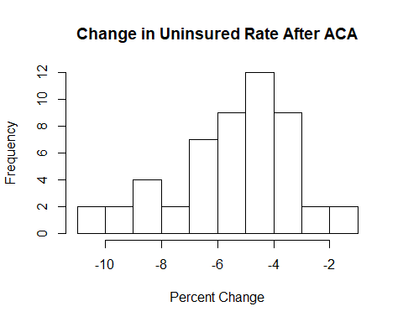

The chart above shows the most frequent percent change was a decrease of 5%. Overall, all states saw a decrease in the uninsured rate after the ACA was enacted.

How did Medicaid enrollment change for states that expanded vs those that didn’t?

States that expanded their Medicaid program saw significantly larger increases in enrollment than those that did not.

format(stat.desc(st_medex), scientific = FALSE)

## State State.Medicaid.Expansion..2016. Medicaid.Enrollment..2013.  
## nbr.val NA NA 49.000000  
## nbr.null NA NA 0.000000  
## nbr.na NA NA 0.000000  
## min NA NA 67518.000000  
## max NA NA 7755381.000000  
## range NA NA 7687863.000000  
## sum NA NA 56392477.000000  
## median NA NA 790051.000000  
## mean NA NA 1150866.877551  
## SE.mean NA NA 209192.034958  
## CI.mean NA NA 420608.776505  
## var NA NA 2144304067009.151367  
## std.dev NA NA 1464344.244708  
## coef.var NA NA 1.272384  
## Medicaid.Enrollment..2016. Medicaid.Enrollment.Change..2013.2016.  
## nbr.val 49.000000 49.000000  
## nbr.null 0.000000 0.000000  
## nbr.na 0.000000 0.000000  
## min 63583.000000 -3935.000000  
## max 11843081.000000 4087700.000000  
## range 11779498.000000 4091635.000000  
## sum 72498634.000000 16106157.000000  
## median 988821.000000 221101.000000  
## mean 1479563.959184 328697.081633  
## SE.mean 280820.088282 84421.193218  
## CI.mean 564626.630140 169740.185364  
## var 3864136177163.331543 349219955351.868225  
## std.dev 1965740.617977 590948.352525  
## coef.var 1.328595 1.797851  
## Medicare.Enrollment..2016.  
## nbr.val 49.000000  
## nbr.null 0.000000  
## nbr.na 0.000000  
## min 88966.000000  
## max 5829777.000000  
## range 5740811.000000  
## sum 54934697.000000  
## median 820234.000000  
## mean 1121116.265306  
## SE.mean 166172.414919  
## CI.mean 334112.033194  
## var 1353050302515.407227  
## std.dev 1163206.904431  
## coef.var 1.037544

st_medex$pct <- st_medex$Medicaid.Enrollment.Change..2013.2016./st_medex$Medicaid.Enrollment..2013. * 100  
ggplot(data = st_medex) + geom_histogram(binwidth = 10, aes(x = pct)) + facet_wrap(~State.Medicaid.Expansion..2016.)

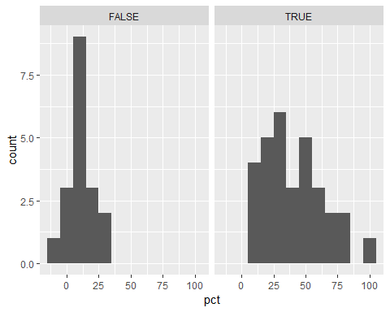

The correlation coefficient displays a positive correlation between states that expanded medicaid and an increase in enrollment. The logistic regression model displays the change in enrollment as a percent to predict if a state has expanded mediciad. The results indicate that as the percent or enrollment increases, there is a good chance that the state expanded.

# Correlation  
cor(st_medex$State.Medicaid.Expansion..2016.,st_medex$pct, method = "kendall" )

## [1] 0.5357584

# Logistic Regression model  
mod <- glm(State.Medicaid.Expansion..2016. ~ pct, data = st_medex, family = binomial())  
summary(mod)

##   
## Call:  
## glm(formula = State.Medicaid.Expansion..2016. ~ pct, family = binomial(),   
## data = st_medex)  
##   
## Deviance Residuals:   
## Min 1Q Median 3Q Max   
## -1.93465 -0.67950 0.08415 0.60565 1.79030   
##   
## Coefficients:  
## Estimate Std. Error z value Pr(>|z|)   
## (Intercept) -2.12365 0.78040 -2.721 0.00650 **  
## pct 0.12452 0.03893 3.198 0.00138 **  
## ---  
## Signif. codes: 0 '***' 0.001 '**' 0.01 '*' 0.05 '.' 0.1 ' ' 1  
##   
## (Dispersion parameter for binomial family taken to be 1)  
##   
## Null deviance: 64.438 on 48 degrees of freedom  
## Residual deviance: 38.494 on 47 degrees of freedom  
## AIC: 42.494  
##   
## Number of Fisher Scoring iterations: 6

plot(mod)

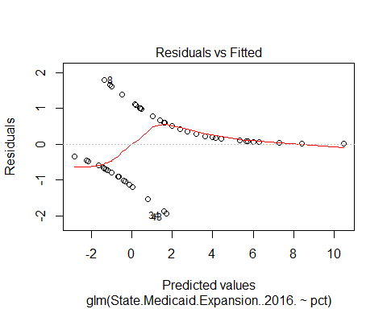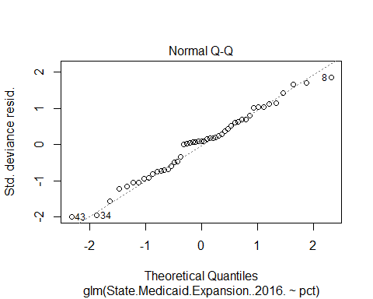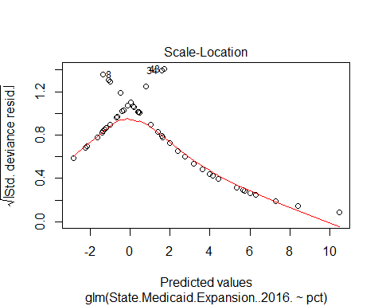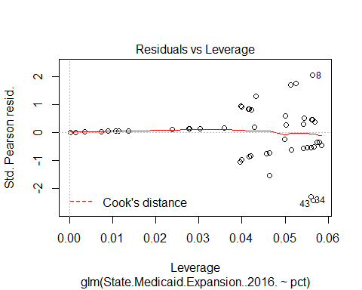

hist(rstudent(mod))

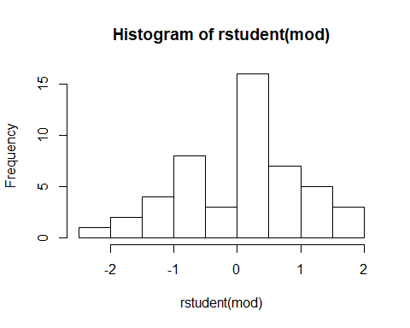

What were the changes in percentages of individuals with prior existing conditions selecting a marketplace plan?

Hawaii saw the smallest percentage of individuals with preexisting conditions selecting a marketplace plan, while Florida had the largest.

format(stat.desc(ind_pre), scientific = FALSE)

## state individuals_with_pre_existing_condition_2009  
## nbr.val NA 51.00000  
## nbr.null NA 0.00000  
## nbr.na NA 0.00000  
## min NA 241133.00000  
## max NA 16133192.00000  
## range NA 15892059.00000  
## sum NA 133936026.00000  
## median NA 1894874.00000  
## mean NA 2626196.58824  
## SE.mean NA 413068.89819  
## CI.mean NA 829673.29938  
## var NA 8701921647091.36719  
## std.dev NA 2949901.97245  
## coef.var NA 1.12326  
## individuals_selecting_a_marketplace_plan_2016  
## nbr.val 51.000000  
## nbr.null 0.000000  
## nbr.na 0.000000  
## min 14564.000000  
## max 1742819.000000  
## range 1728255.000000  
## sum 12681874.000000  
## median 147109.000000  
## mean 248664.196078  
## SE.mean 50099.709867  
## CI.mean 100628.228767  
## var 128009027367.320786  
## std.dev 357783.492307  
## coef.var 1.438822

ind_pre$pct <- ind_pre$individuals_selecting_a_marketplace_plan_2016/ind_pre$individuals_with_pre_existing_condition_2009 * 100  
  
# State with largest percentage of individuals selecting a marketplace plan  
ind_pre[which.max(ind_pre$pct),]

## state individuals_with_pre_existing_condition_2009  
## 10 Florida 7838642  
## individuals_selecting_a_marketplace_plan_2016 pct  
## 10 1742819 22.23369

# State with smallest percentage of individuals selecting a marketplace plan  
ind_pre[which.min(ind_pre$pct),]

## state individuals_with_pre_existing_condition_2009  
## 12 Hawaii 560494  
## individuals_selecting_a_marketplace_plan_2016 pct  
## 12 14564 2.598422

#States with largest percentage of individuals selecting a marketplace plan  
ind_pre[order(ind_pre$pct, decreasing = T)[1:5],]

## state individuals_with_pre_existing_condition_2009  
## 10 Florida 7838642  
## 45 Utah 1150918  
## 13 Idaho 662319  
## 34 North Carolina 4099922  
## 20 Maine 590266  
## individuals_selecting_a_marketplace_plan_2016 pct  
## 10 1742819 22.23369  
## 45 175637 15.26060  
## 13 101073 15.26047  
## 34 613487 14.96338  
## 20 84059 14.24087

#States with smallest percentage of individuals selecting a marketplace plan  
ind_pre[order(ind_pre$pct)[1:5],]

## state individuals_with_pre_existing_condition_2009  
## 12 Hawaii 560494  
## 33 New York 8616234  
## 24 Minnesota 2318738  
## 16 Iowa 1290303  
## 49 West Virginia 799920  
## individuals_selecting_a_marketplace_plan_2016 pct  
## 12 14564 2.598422  
## 33 271964 3.156414  
## 24 83507 3.601399  
## 16 55089 4.269462  
## 49 37284 4.660966

hist(ind_pre$pct, main = "Individuals With Pre-existing Conditions Selecting Marketplace Plan", xlab = "Percent")

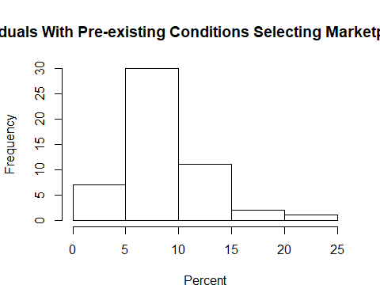

This chart shows the frequency of individuals with pre-existing conditions in 2009 selecting marketplace insurance in 2016. In 30 states, this was 8%.

Individuals with marketplace plans receiving tax credits and cost sharing reductions, vs individuals eligible for tax credit but purchasing off market insurance

ind_txcr$txcrpct <- ind_txcr$individuals_receiving_tax_credits_q1_2016/ind_txcr$individuals_with_marketplace_coverage_q1_2016*100  
ind_txcr$cstshrpct <- ind_txcr$individuals_receiving_cost_sharing_reductions_q1_2016/ind_txcr$individuals_with_marketplace_coverage_q1_2016*100  
  
format(stat.desc(ind_txcr), scientific = FALSE)

## state individuals_with_marketplace_coverage_q1_2016  
## nbr.val NA 51.000000  
## nbr.null NA 0.000000  
## nbr.na NA 0.000000  
## min NA 13313.000000  
## max NA 1531714.000000  
## range NA 1518401.000000  
## sum NA 11081330.000000  
## median NA 130178.000000  
## mean NA 217280.980392  
## SE.mean NA 43909.906858  
## CI.mean NA 88195.643531  
## var NA 98332075933.499603  
## std.dev NA 313579.457129  
## coef.var NA 1.443198  
## individuals_receiving_tax_credits_q1_2016  
## nbr.val 51.000000  
## nbr.null 0.000000  
## nbr.na 0.000000  
## min 1224.000000  
## max 1428712.000000  
## range 1427488.000000  
## sum 9389609.000000  
## median 95507.000000  
## mean 184109.980392  
## SE.mean 39379.902246  
## CI.mean 79096.861490  
## var 79089611745.939606  
## std.dev 281228.753412  
## coef.var 1.527504  
## individuals_receiving_cost_sharing_reductions_q1_2016  
## nbr.val 51.000000  
## nbr.null 0.000000  
## nbr.na 0.000000  
## min 279.000000  
## max 1125850.000000  
## range 1125571.000000  
## sum 6353551.000000  
## median 58781.000000  
## mean 124579.431373  
## SE.mean 28041.933565  
## CI.mean 56323.881184  
## var 40103851942.290199  
## std.dev 200259.461555  
## coef.var 1.607484  
## purchasing_off_market_who_could_quality_for_tax_credits_2016  
## nbr.val 51.000000  
## nbr.null 0.000000  
## nbr.na 0.000000  
## min 1000.000000  
## max 313000.000000  
## range 312000.000000  
## sum 2489000.000000  
## median 31000.000000  
## mean 48803.921569  
## SE.mean 8403.361587  
## CI.mean 16878.648488  
## var 3601440784.313725  
## std.dev 60012.005335  
## coef.var 1.229655  
## txcrpct cstshrpct  
## nbr.val 51.0000000 51.0000000  
## nbr.null 0.0000000 0.0000000  
## nbr.na 0.0000000 0.0000000  
## min 6.9285633 1.5793049  
## max 94.2107091 77.6287188  
## range 87.2821458 76.0494139  
## sum 4129.7023575 2656.7554006  
## median 84.9229133 53.3807171  
## mean 80.9745560 52.0932431  
## SE.mean 1.9560072 2.0560841  
## CI.mean 3.9287561 4.1297664  
## var 195.1241753 215.6015692  
## std.dev 13.9686855 14.6833773  
## coef.var 0.1725071 0.2818672

ggplot(ind_txcr, aes(individuals_with_marketplace_coverage_q1_2016, purchasing_off_market_who_could_quality_for_tax_credits_2016)) + geom_point() + geom_smooth(method = "lm", se = F) + labs(title = "Individuals Qualified for Tax Credits", x = "Individuals Purchasing Marketplace Coverage", y = "Individuals Purchasing Off Market")

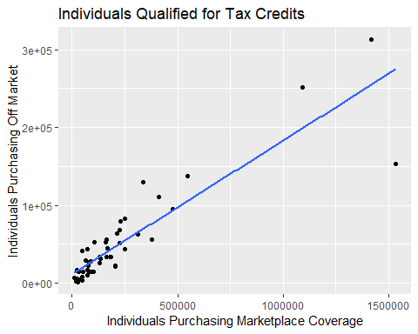

This chart shows individuals that qualified for tax credits, and compares those purchasing marketplace coverage vs. those that purchased off market coverage.

The correlation coefficient shows a strong, positive relationship between individuals with marketplace coverage and individuals qualified for tax credits that purchase off market coverage.

The regression model uses variables for individuals receiving tax credits or cost sharing reductions predicting individuals with marketplace coverage. The model indicates that the two variables explain 99.6% of the variance in individuals with marketplace coverage.

# Correlation  
cor(ind_txcr$individuals_with_marketplace_coverage_q1_2016,ind_txcr$purchasing_off_market_who_could_quality_for_tax_credits_2016, method = "kendall" )

## [1] 0.7216198

# Regression model  
mod2 <- lm(individuals_with_marketplace_coverage_q1_2016~individuals_receiving_tax_credits_q1_2016 + individuals_receiving_cost_sharing_reductions_q1_2016, data = ind_txcr)  
summary(mod2)

##   
## Call:  
## lm(formula = individuals_with_marketplace_coverage_q1_2016 ~   
## individuals_receiving_tax_credits_q1_2016 + individuals_receiving_cost_sharing_reductions_q1_2016,   
## data = ind_txcr)  
##   
## Residuals:  
## Min 1Q Median 3Q Max   
## -32667 -10955 -6384 4117 67712   
##   
## Coefficients:  
## Estimate  
## (Intercept) 1.077e+04  
## individuals_receiving_tax_credits_q1_2016 1.362e+00  
## individuals_receiving_cost_sharing_reductions_q1_2016 -3.547e-01  
## Std. Error t value  
## (Intercept) 3.340e+03 3.225  
## individuals_receiving_tax_credits_q1_2016 6.336e-02 21.490  
## individuals_receiving_cost_sharing_reductions_q1_2016 8.898e-02 -3.986  
## Pr(>|t|)   
## (Intercept) 0.002268 **   
## individuals_receiving_tax_credits_q1_2016 < 2e-16 ***  
## individuals_receiving_cost_sharing_reductions_q1_2016 0.000228 ***  
## ---  
## Signif. codes: 0 '***' 0.001 '**' 0.01 '*' 0.05 '.' 0.1 ' ' 1  
##   
## Residual standard error: 19720 on 48 degrees of freedom  
## Multiple R-squared: 0.9962, Adjusted R-squared: 0.996   
## F-statistic: 6294 on 2 and 48 DF, p-value: < 2.2e-16

plot(mod2)

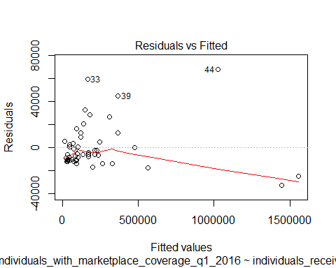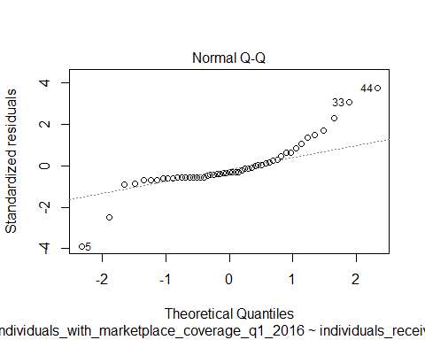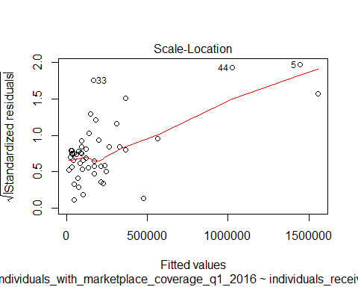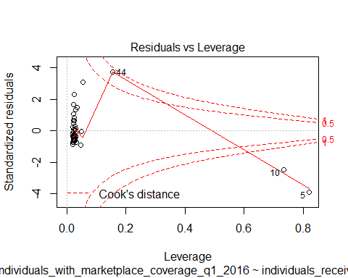

hist(rstudent(mod2))

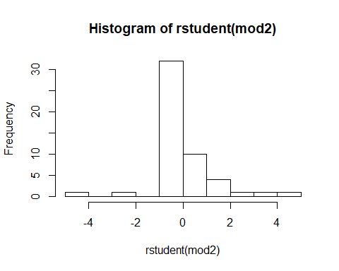

What is the change in premiums, comparing 2000-2010 rate changes to 2010-2015 rate changes?

New York had the highest growth in premiums for employee coverage, while Florida had the lowest

format(stat.desc(emp_prem), scientific = FALSE)

## state people_with_employer_coverage_2015  
## nbr.val NA 40.0000000  
## nbr.null NA 0.0000000  
## nbr.na NA 0.0000000  
## min NA 449000.0000000  
## max NA 19552000.0000000  
## range NA 19103000.0000000  
## sum NA 165253000.0000000  
## median NA 3303500.0000000  
## mean NA 4131325.0000000  
## SE.mean NA 600481.8475314  
## CI.mean NA 1214589.1806487  
## var NA 14423137968589.7441406  
## std.dev NA 3797780.6635705  
## coef.var NA 0.9192646  
## avg_annual_growth_in_fam_premiums_for_emp_cov_2000_2010  
## nbr.val 40.00000000  
## nbr.null 0.00000000  
## nbr.na 0.00000000  
## min 6.40000000  
## max 8.70000000  
## range 2.30000000  
## sum 292.60000000  
## median 7.30000000  
## mean 7.31500000  
## SE.mean 0.09188552  
## CI.mean 0.18585601  
## var 0.33771795  
## std.dev 0.58113505  
## coef.var 0.07944430  
## avg_annual_growth_family_prem_for_emp_cov_2010_2015  
## nbr.val 40.0000000  
## nbr.null 0.0000000  
## nbr.na 0.0000000  
## min 1.3000000  
## max 5.9000000  
## range 4.6000000  
## sum 181.5000000  
## median 4.7500000  
## mean 4.5375000  
## SE.mean 0.1409077  
## CI.mean 0.2850126  
## var 0.7941987  
## std.dev 0.8911783  
## coef.var 0.1964029  
## family_emp_prem_savings_comp_cont_growth_pre_aca_rate_2015  
## nbr.val 40.000000  
## nbr.null 0.000000  
## nbr.na 0.000000  
## min 700.000000  
## max 6300.000000  
## range 5600.000000  
## sum 96200.000000  
## median 2200.000000  
## mean 2405.000000  
## SE.mean 182.537316  
## CI.mean 369.216572  
## var 1332794.871795  
## std.dev 1154.467354  
## coef.var 0.480028  
## family_emp_prem_savings_comp_cont_growth_pre_aca_rate_2016  
## nbr.val 40.0000000  
## nbr.null 0.0000000  
## nbr.na 0.0000000  
## min 1300.0000000  
## max 7600.0000000  
## range 6300.0000000  
## sum 130100.0000000  
## median 3000.0000000  
## mean 3252.5000000  
## SE.mean 211.4354936  
## CI.mean 427.6686531  
## var 1788198.7179487  
## std.dev 1337.2354759  
## coef.var 0.4111408

#States with highest growth in premiums for employee coverage  
emp_prem[which.max(emp_prem$avg_annual_growth_family_prem_for_emp_cov_2010_2015),]

## state people_with_employer_coverage_2015  
## 33 New York 10895000  
## avg_annual_growth_in_fam_premiums_for_emp_cov_2000_2010  
## 33 7.6  
## avg_annual_growth_family_prem_for_emp_cov_2010_2015  
## 33 5.9  
## family_emp_prem_savings_comp_cont_growth_pre_aca_rate_2015  
## 33 1600  
## family_emp_prem_savings_comp_cont_growth_pre_aca_rate_2016  
## 33 2500

#States with lowest growth in premiums for employee coverage  
emp_prem[which.min(emp_prem$avg_annual_growth_family_prem_for_emp_cov_2010_2015),]

## state people_with_employer_coverage_2015  
## 10 Florida 8847000  
## avg_annual_growth_in_fam_premiums_for_emp_cov_2000_2010  
## 10 8.2  
## avg_annual_growth_family_prem_for_emp_cov_2010_2015  
## 10 1.3  
## family_emp_prem_savings_comp_cont_growth_pre_aca_rate_2015  
## 10 6300  
## family_emp_prem_savings_comp_cont_growth_pre_aca_rate_2016  
## 10 7600

#States with largest annual growth in premiums 2010 - 2015  
emp_prem[order(emp_prem$avg_annual_growth_family_prem_for_emp_cov_2010_2015, decreasing = T)[1:5],]

## state people_with_employer_coverage_2015  
## 33 New York 10895000  
## 11 Georgia 5240000  
## 26 Missouri 3389000  
## 5 California 19552000  
## 19 Louisiana 2295000  
## avg_annual_growth_in_fam_premiums_for_emp_cov_2000_2010  
## 33 7.6  
## 11 7.0  
## 26 6.6  
## 5 8.3  
## 19 7.3  
## avg_annual_growth_family_prem_for_emp_cov_2010_2015  
## 33 5.9  
## 11 5.7  
## 26 5.7  
## 5 5.5  
## 19 5.4  
## family_emp_prem_savings_comp_cont_growth_pre_aca_rate_2015  
## 33 1600  
## 11 1100  
## 26 700  
## 5 2500  
## 19 1600  
## family_emp_prem_savings_comp_cont_growth_pre_aca_rate_2016  
## 33 2500  
## 11 1800  
## 26 1300  
## 5 3600  
## 19 2400

#States with smallest annual growth in premiums 2010 - 2015  
emp_prem[order(emp_prem$avg_annual_growth_family_prem_for_emp_cov_2010_2015)[1:5],]

## state people_with_employer_coverage_2015  
## 10 Florida 8847000  
## 14 Illinois 7359000  
## 25 Mississippi 1326000  
## 48 Washington 3986000  
## 23 Michigan 5876000  
## avg_annual_growth_in_fam_premiums_for_emp_cov_2000_2010  
## 10 8.2  
## 14 7.4  
## 25 8.7  
## 48 8.1  
## 23 6.8  
## avg_annual_growth_family_prem_for_emp_cov_2010_2015  
## 10 1.3  
## 14 3.2  
## 25 3.2  
## 48 3.2  
## 23 3.5  
## family_emp_prem_savings_comp_cont_growth_pre_aca_rate_2015  
## 10 6300  
## 14 3800  
## 25 4700  
## 48 4300  
## 23 2600  
## family_emp_prem_savings_comp_cont_growth_pre_aca_rate_2016  
## 10 7600  
## 14 4700  
## 25 6000  
## 48 5500  
## 23 3300

labs <- c("2015", "2016")  
temp <- emp_prem[, c(1, 5, 6)]  
temp <- melt(temp)  
variable_names <- c("family_emp_prem_savings_comp_cont_growth_pre_aca_rate_2015" = "2015", "family_emp_prem_savings_comp_cont_growth_pre_aca_rate_2016" = "2016")  
ggplot(temp, aes(value, fill = factor(variable, labels = c("2015", "2016")))) + geom_histogram(binwidth=1000) + facet_grid(variable~., labeller = as_labeller(variable_names)) + labs(title = "Employer Premium Savings Rate", fill = "Year")

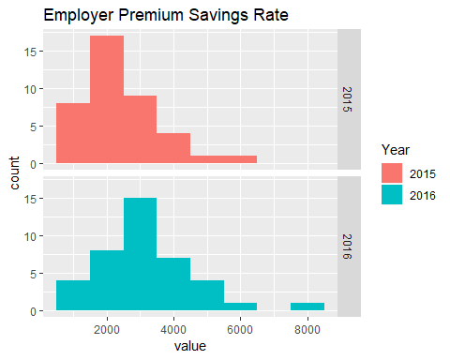

What is the trend or change in Medical Loss Ratio (MLR) rebates for insurance providers?

The rate was largest in 2012, with a large dip in 2013. Over the years of 2014 and 2015, the change has trended upwards towards 2012 numbers again.

format(stat.desc(emp_mlr), scientific = FALSE)

## state  
## nbr.val NA  
## nbr.null NA  
## nbr.na NA  
## min NA  
## max NA  
## range NA  
## sum NA  
## median NA  
## mean NA  
## SE.mean NA  
## CI.mean NA  
## var NA  
## std.dev NA  
## coef.var NA  
## total_group_market_consumers_benefiting_from_mlr_rebates_2012  
## nbr.val 51.000000  
## nbr.null 2.000000  
## nbr.na 0.000000  
## min 0.000000  
## max 1088504.000000  
## range 1088504.000000  
## sum 5692005.000000  
## median 39589.000000  
## mean 111607.941176  
## SE.mean 25841.564752  
## CI.mean 51904.310353  
## var 34057109909.256470  
## std.dev 184545.685155  
## coef.var 1.653518  
## total_group_market_rebates_2012  
## nbr.val 51.000000  
## nbr.null 2.000000  
## nbr.na 0.000000  
## min 0.000000  
## max 47272420.000000  
## range 47272420.000000  
## sum 305966504.000000  
## median 2085935.000000  
## mean 5999343.215686  
## SE.mean 1319141.062553  
## CI.mean 2649572.801338  
## var 88746790288650.656250  
## std.dev 9420551.485378  
## coef.var 1.570264  
## total_group_market_consumers_benefiting_from_mlr_rebates_2013  
## nbr.val 51.000000  
## nbr.null 7.000000  
## nbr.na 0.000000  
## min 0.000000  
## max 622688.000000  
## range 622688.000000  
## sum 4597526.000000  
## median 40084.000000  
## mean 90147.568627  
## SE.mean 19190.172110  
## CI.mean 38544.595054  
## var 18781397986.010197  
## std.dev 137045.240654  
## coef.var 1.520232  
## total_group_market_rebates_2013  
## nbr.val 51.000000  
## nbr.null 7.000000  
## nbr.na 0.000000  
## min 0.000000  
## max 23692538.000000  
## range 23692538.000000  
## sum 197758659.000000  
## median 1870997.000000  
## mean 3877620.764706  
## SE.mean 654683.986602  
## CI.mean 1314971.486836  
## var 21859167237973.582031  
## std.dev 4675378.833632  
## coef.var 1.205734  
## total_group_market_consumers_benefiting_from_mlr_rebates_2014  
## nbr.val 51.00000  
## nbr.null 10.00000  
## nbr.na 0.00000  
## min 0.00000  
## max 592343.00000  
## range 592343.00000  
## sum 3392766.00000  
## median 22166.00000  
## mean 66524.82353  
## SE.mean 16158.76038  
## CI.mean 32455.82540  
## var 13316382390.50824  
## std.dev 115396.63076  
## coef.var 1.73464  
## total_group_market_rebates_2014  
## nbr.val 51.000000  
## nbr.null 10.000000  
## nbr.na 0.000000  
## min 0.000000  
## max 33422223.000000  
## range 33422223.000000  
## sum 231135152.000000  
## median 1303715.000000  
## mean 4532061.803922  
## SE.mean 1046835.440076  
## CI.mean 2102630.862035  
## var 55889086368546.484375  
## std.dev 7475900.371764  
## coef.var 1.649558  
## total_group_market_consumers_benefiting_from_mlr_rebates_2015  
## nbr.val 51.000000  
## nbr.null 16.000000  
## nbr.na 0.000000  
## min 0.000000  
## max 615309.000000  
## range 615309.000000  
## sum 3662047.000000  
## median 3935.000000  
## mean 71804.843137  
## SE.mean 19668.789957  
## CI.mean 39505.927293  
## var 19729926217.774902  
## std.dev 140463.255757  
## coef.var 1.956181  
## total_group_market_rebates_2015  
## nbr.val 51.000000  
## nbr.null 16.000000  
## nbr.na 0.000000  
## min 0.000000  
## max 45189590.000000  
## range 45189590.000000  
## sum 289324017.000000  
## median 737553.000000  
## mean 5673019.941176  
## SE.mean 1514727.679481  
## CI.mean 3042420.082973  
## var 117014397092303.421875  
## std.dev 10817319.311747  
## coef.var 1.906801  
## total_group_market_rebates_2012_2015  
## nbr.val 51.000000  
## nbr.null 2.000000  
## nbr.na 0.000000  
## min 0.000000  
## max 124910743.000000  
## range 124910743.000000  
## sum 1024184332.000000  
## median 6366291.000000  
## mean 20082045.725490  
## SE.mean 4030027.562100  
## CI.mean 8094548.581873  
## var 828297229715523.125000  
## std.dev 28780153.399791  
## coef.var 1.433129

temp2 <- emp_mlr[, c(1, 3, 5, 7, 9)]  
temp2 <- melt(temp2)  
  
ggplot(temp2, aes(factor(variable), value)) + stat_summary(fun.y = mean, geom = "line", aes(group = 1)) + labs(title = "Employee MLR", x = "Year")

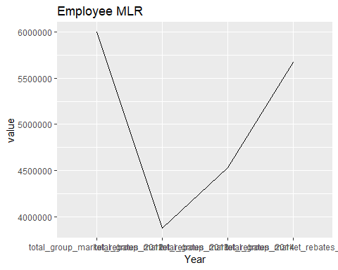

ggplot(temp2, aes(value, factor(variable, labels = c("2012", " 2013", "2014", "2015")))) + geom_point(aes(color = factor(variable, labels = c("2012", " 2013", "2014", "2015")))) + labs(y = "Year", color = "Years")

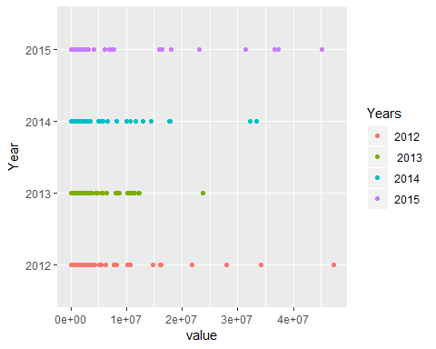

ggplot(temp2, aes(value, fill = factor(variable,labels = c("2012", " 2013", "2014", "2015")))) + geom_density(aes(value)) + labs(fill = "Year")

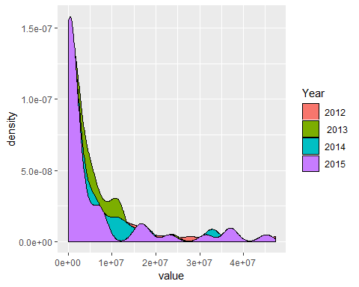

How has Medicare been impacted, as in free services utilized, the “donut hole gap” in prescription coverage, or changes in hospital readmission rates?

The correlation coefficient shows a small, negative relationship between hospital readmission rates for medicare beneficiaries and those beneficiaries using free preventive services. This shows a decrease in readmission rates for those using free services.

The regression model uses the variables for beneficiaries using free preventive services and donut savings to predict the change in hospital readmission rates amoung beneficiaries. The model indicates that the two variables can account for 19% of the change in the readmission rate.

med_imp$sh_donut <- med_imp$medicare_beneficiaries_benefitting_from_donut_hole_savings_2015/med_imp$medicare_enrollment_sept_2016  
  
# Correlation  
cor(med_imp$change_in_hospital_readmission_rates_among_medicare_beneficiaries_2010_2015, med_imp$share_of_part_b_beneficiaries_using_free_preventive_services_2015, method = "kendall" )

## [1] -0.1536648

#Logistic Regression Model  
mod3 <- lm(change_in_hospital_readmission_rates_among_medicare_beneficiaries_2010_2015~share_of_part_b_beneficiaries_using_free_preventive_services_2015 + sh_donut, data = med_imp)  
summary(mod3)

##   
## Call:  
## lm(formula = change_in_hospital_readmission_rates_among_medicare_beneficiaries_2010_2015 ~   
## share_of_part_b_beneficiaries_using_free_preventive_services_2015 +   
## sh_donut, data = med_imp)  
##   
## Residuals:  
## Min 1Q Median 3Q Max   
## -5.4871 -1.9798 0.0075 1.3298 7.4743   
##   
## Coefficients:  
## Estimate  
## (Intercept) -3.17606  
## share_of_part_b_beneficiaries_using_free_preventive_services_2015 0.02982  
## sh_donut -71.63422  
## Std. Error  
## (Intercept) 6.96906  
## share_of_part_b_beneficiaries_using_free_preventive_services_2015 0.11390  
## sh_donut 26.11099  
## t value  
## (Intercept) -0.456  
## share_of_part_b_beneficiaries_using_free_preventive_services_2015 0.262  
## sh_donut -2.743  
## Pr(>|t|)  
## (Intercept) 0.65063  
## share_of_part_b_beneficiaries_using_free_preventive_services_2015 0.79458  
## sh_donut 0.00852  
##   
## (Intercept)   
## share_of_part_b_beneficiaries_using_free_preventive_services_2015   
## sh_donut **  
## ---  
## Signif. codes: 0 '***' 0.001 '**' 0.01 '*' 0.05 '.' 0.1 ' ' 1  
##   
## Residual standard error: 2.797 on 48 degrees of freedom  
## Multiple R-squared: 0.1894, Adjusted R-squared: 0.1556   
## F-statistic: 5.607 on 2 and 48 DF, p-value: 0.006479

plot(mod3)

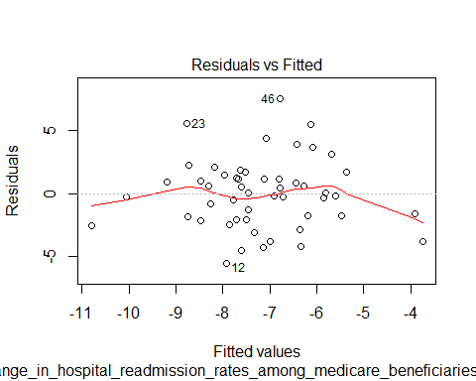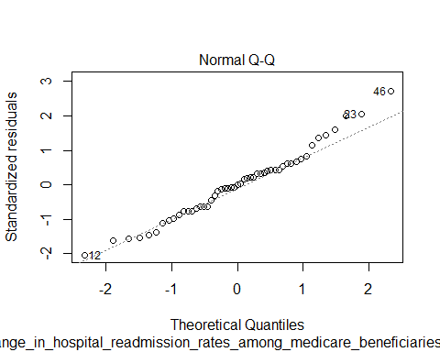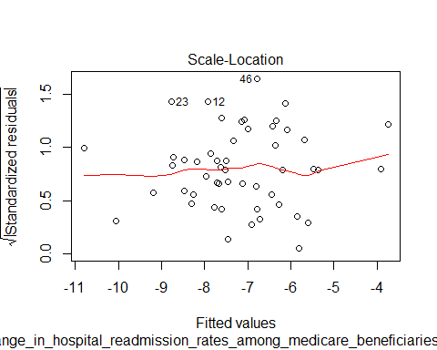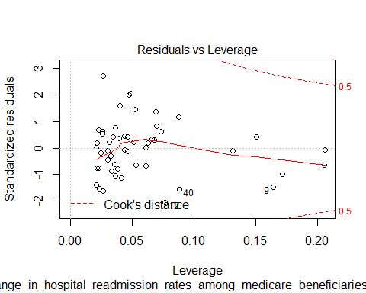

hist(rstudent(mod3))

